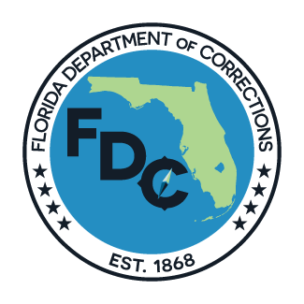
STATE OF FLORIDA

DEPARTMENT OF CORRECTIONS

VICTIM INFORMATION AND NOTIFICATION REQUEST
In compliance with 944.605, Florida Statutes

If you are not a victim, access VINE directly at VINELink.com to register for notifications

- Inmate/Offender Information:  Please provide as much information as possible to ensure we registered you for the correct inmate.  Complete a separate form for each inmate/offender. | DC Number: _________________ ICOTS Number: _________________  Inmate/Offender NAME: _______________________________________  R/S: ___/___ DOB: ___________  Case Number: ____________________ County: ________________  Crime: ______________________________________________
- Your information:  If you are requesting VINE notifications, please mark the appropriate box.  Note that phone notifications will continue to call you until you enter your 4 digit PIN. Text and email notifications do no repeat.  PIN = Any 4 digits. Will default to last 4 of the phone number if not chosen. | Name: ____________________________________ DOB: ___________  Address: __________________________________________  City/State/Zip: __________________________________________  Telephone: (Home) XXXXXXXXXX VINE Notifications: Phone Text PIN ____  (Work) XXXXXXXXXX  (Cell) XXXXXXXXXX VINE Notifications: Phone Text PIN ____  Email: ___________________________________ VINE Registration: Yes  Notification Language, if other than English: Spanish Creole
- If you are NOT the actual victim: | Victim`s Name: __________________________________________  Your relationship to the Inmate: ___________________________________  Your relationship to the Victim: ___________________________________  Is the victim deceased: Yes  Is the victim a minor: Yes Minor’s DOB: ___________________________
- To better assist you, if you are the victim, survivor or representative for the victim regarding the current case, this is your opportunity to provide us with important information. If you are not the current victim/survivor/representative, please explain why you wish to be notified. (Attach additional pages, if necessary.): ______________________________________________________________________________________________________________________________________________________________________________
Upon completion, submit form to: | Victim.Services@FDC.MyFlorida.com , or | Victim Services  Florida Department of Corrections  501 South Calhoun Street  Tallahassee, FL 32399-2500
For assistance, contact our office toll-free at 1-877-884-2846, Monday through Friday, 8 a.m. to 5 p.m. Eastern Time. You may also call directly to our VINE Service for offender information toll-free at 1-877-846-3435, 24 hours a day, 7 days a week.
Victims are strongly encouraged to notify the Department of any change in contact information.
Updating VINE does not update your information with the Department.

